**COMPUTER NETWROKS SEMESTER FINAL PROJECT  
SMART CITY VLAN SYSTEM   
  
MUHAMMAD SAAD ZIA 232394  
AHMAD RASHID 232385**  
  


SUBMITTED TO:  
MISS KAINAT NAZIR

# Project Overview

This project simulates a fully functional Smart City network in Cisco Packet Tracer. The city is divided into six departments: Bank, Tax, Health, Government, Fire, and School. Each department uses VLANs, routers, and switches for secure, interconnected communication. The core architecture includes three regional routers and one central router to manage inter-region routing.

An Email Server has been deployed in the Smart City network to allow inter-department communication via electronic mail, mimicking real-world enterprise infrastructure. It supports both sending and receiving services using SMTP and POP3 protocols. - Server Details: - IP Address: 192.168.80.2 - Subnet Mask: 255.255.255.0 - Default Gateway: 192.168.80.1

# Network Topology Overview

The image below shows the complete network layout with colored zones for each department.

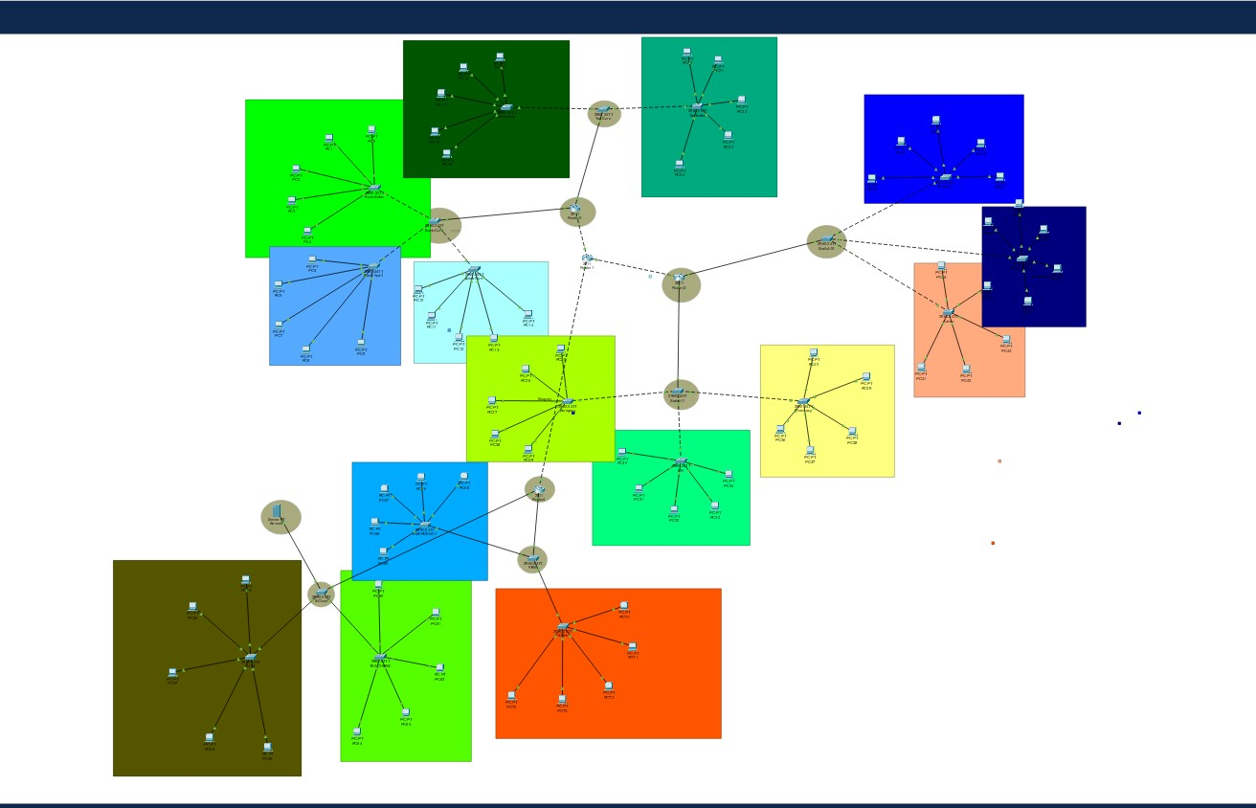

**3. Router Configurations**

Each router handles multiple VLAN subinterfaces and connects to the central router. Below are CLI outputs:

# Router 1 - Interfaces

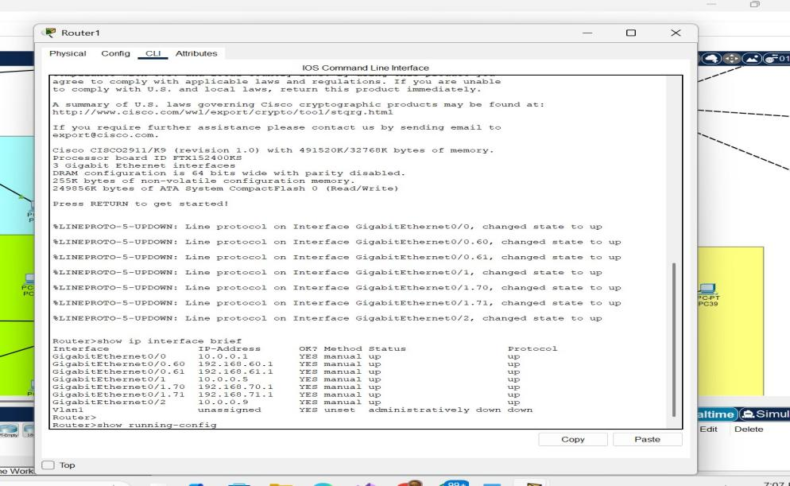

# Router 2 - Interfaces

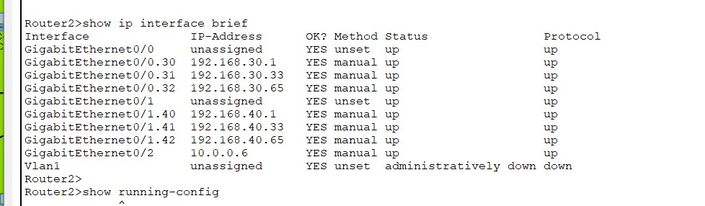

# Router 1 - Interfaces

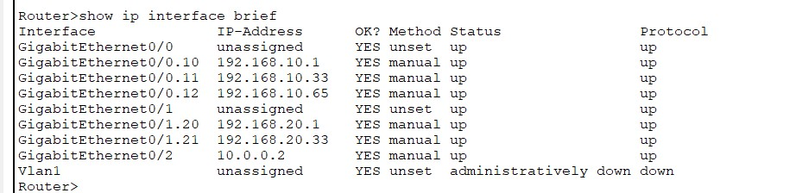

# Router 3 - Interfaces

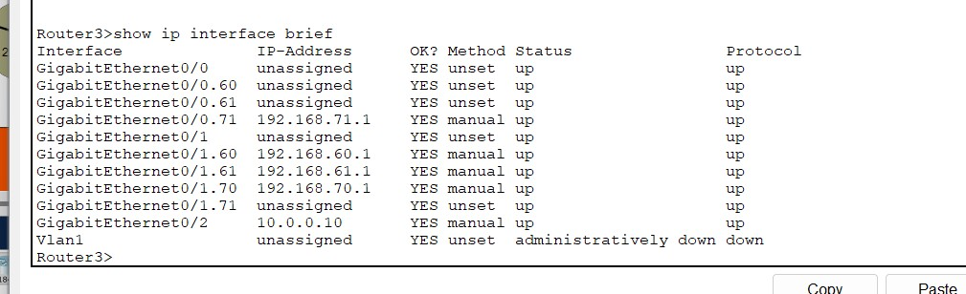

**4. Core Switch VLAN and Trunk Configurations**

Below are the 'show vlan brief' and 'show interfaces trunk' outputs from different department core switches.

# Bank Core - VLAN and Trunk Info

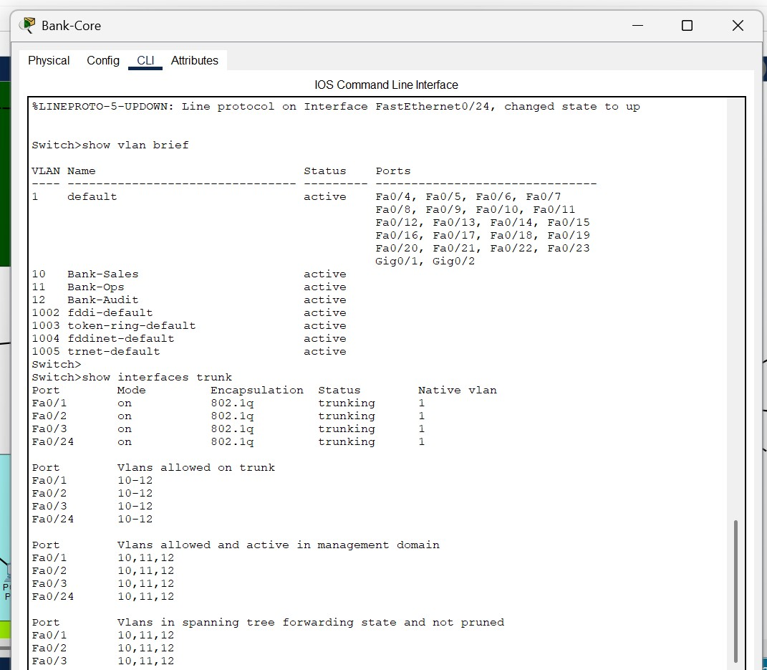

# Tax Core - VLAN and Trunk Info

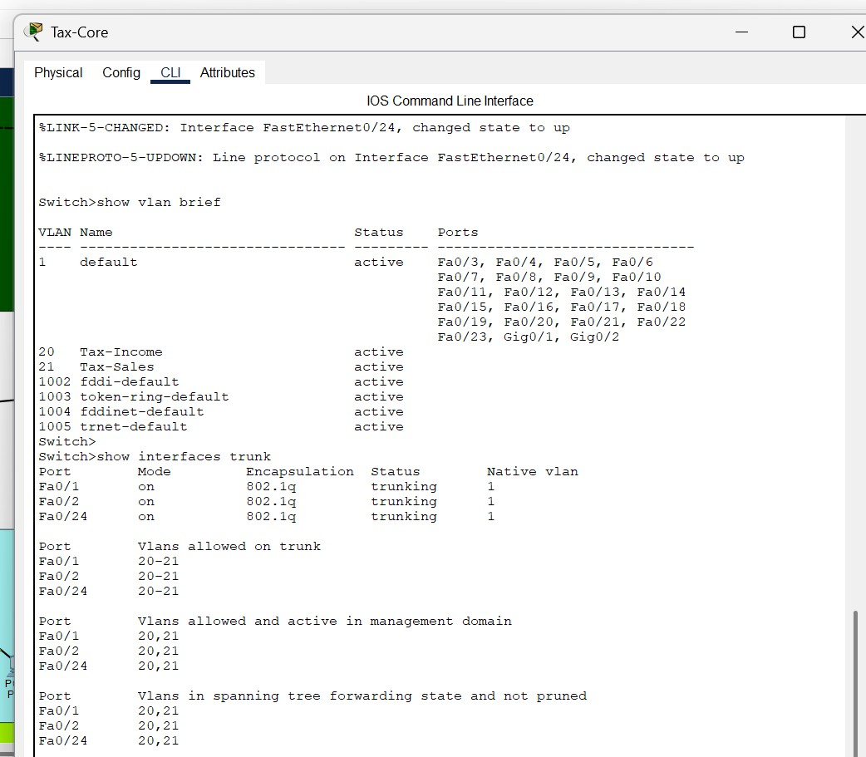

# Government Core - VLAN and Trunk Info

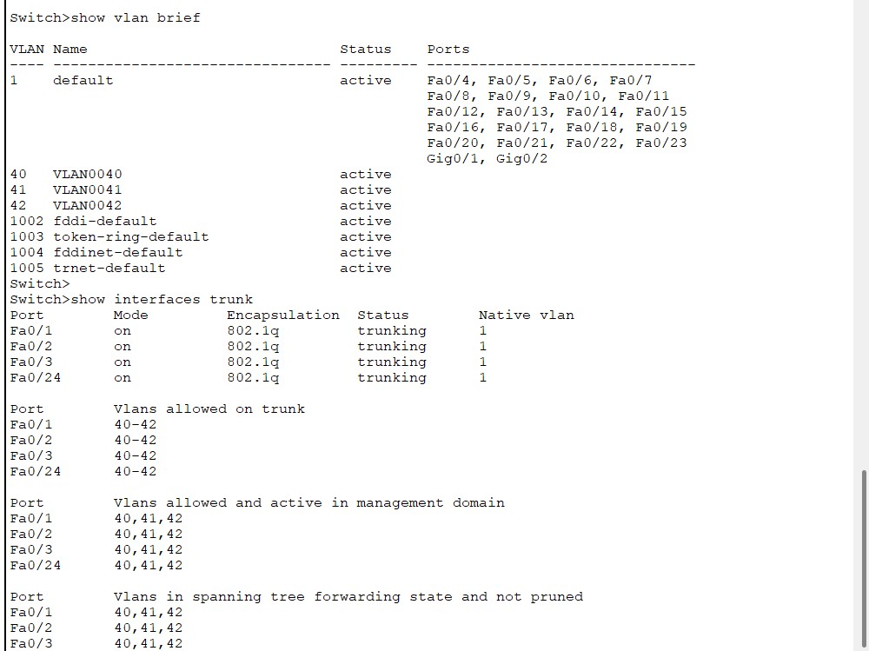

# Health Core - VLAN and Trunk Info

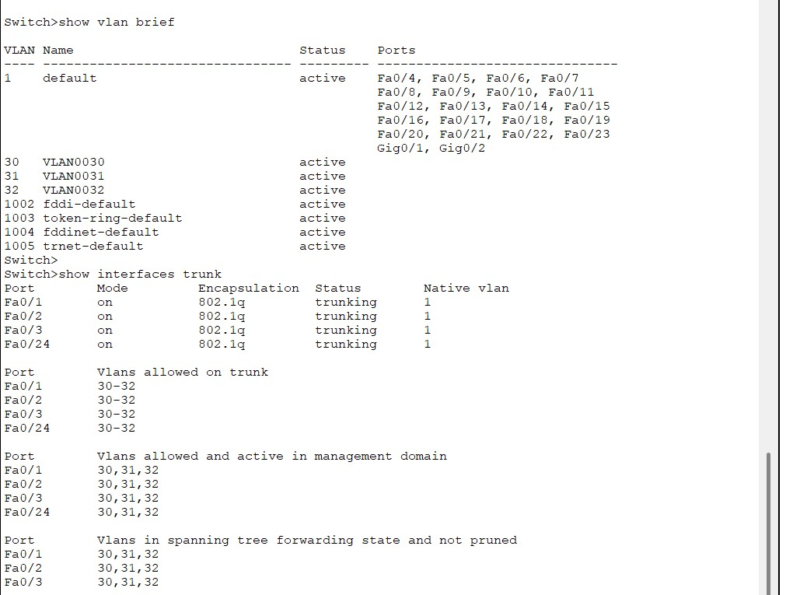

# School Core - VLAN and Trunk Info

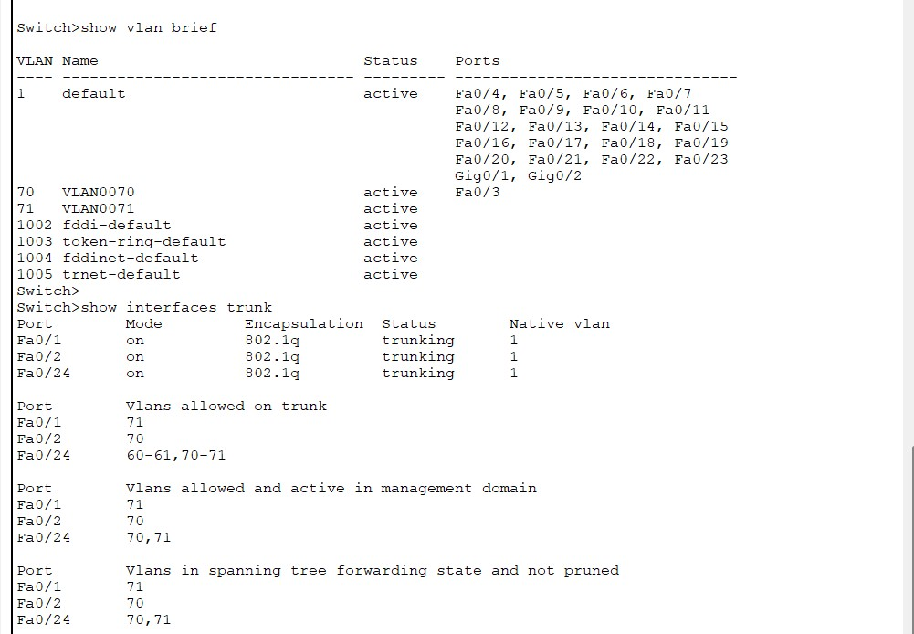

PING TEST:

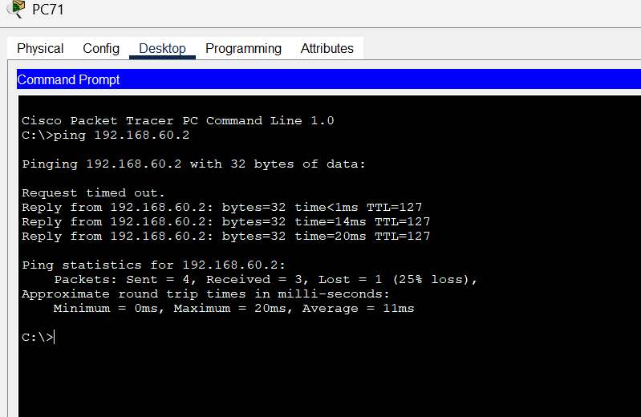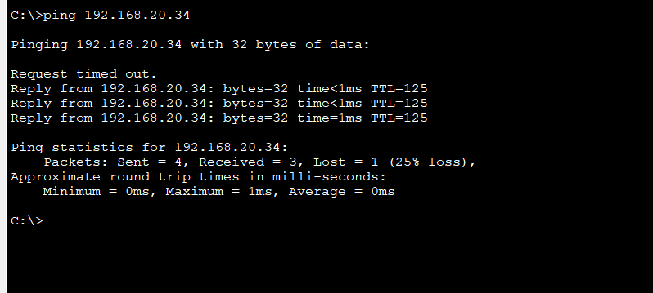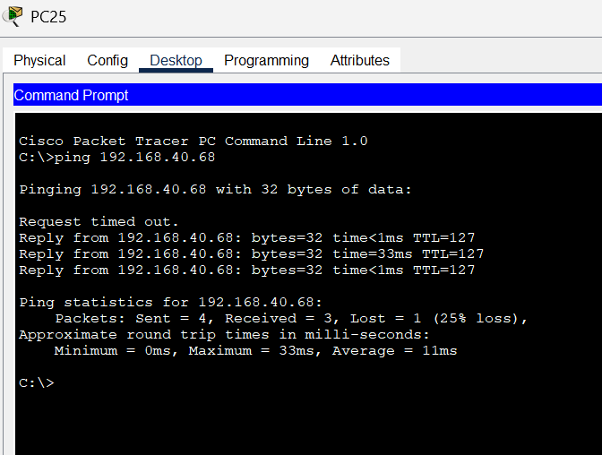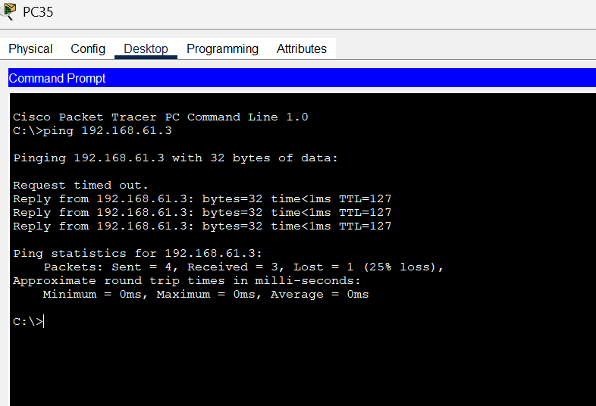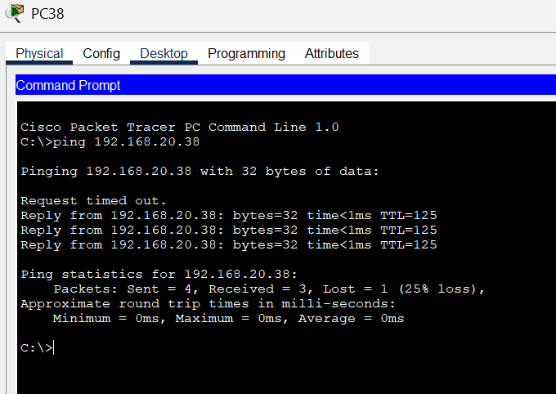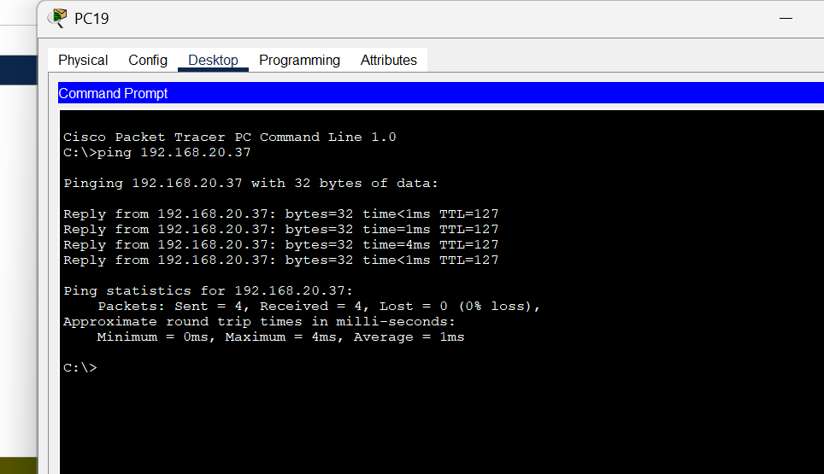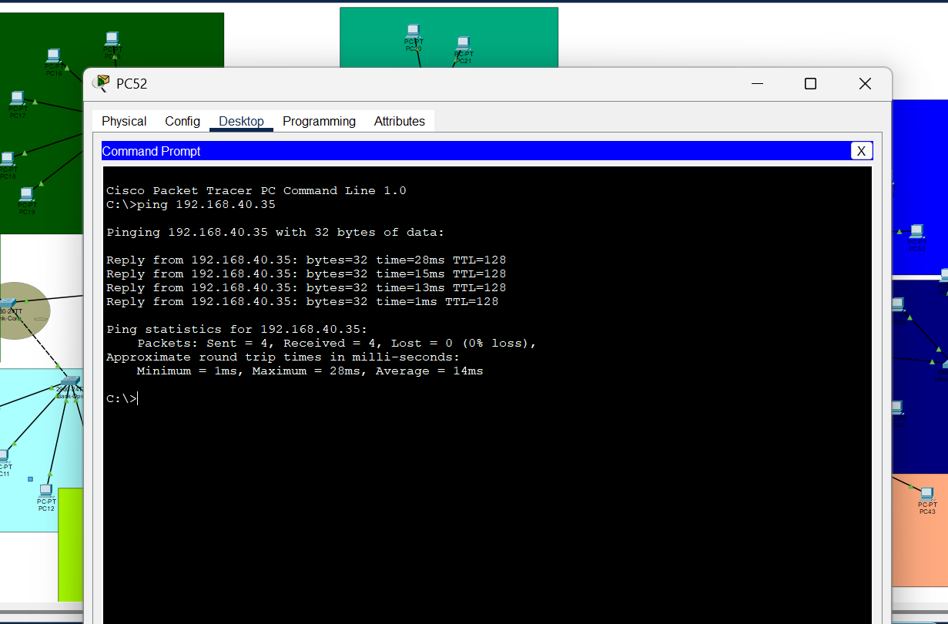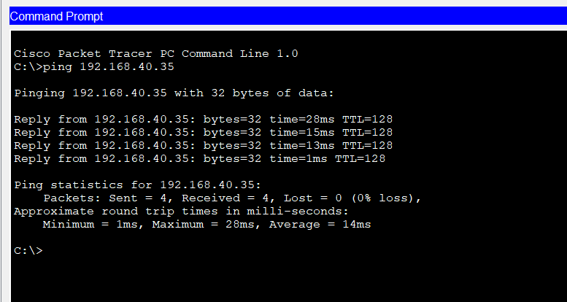

**Conclusion**

The Smart City network simulation successfully demonstrates the design and implementation of a secure, scalable, and segmented network using VLANs, routers, and core/access switches. By logically separating departments such as Bank, Tax, Health, Government, Fire, and School through VLANs and interconnecting them via routed links, the project ensures efficient communication and traffic control across the entire city infrastructure.

Through static routing, trunking, and server integration (including DNS and Email Server), the network supports real-time inter-department communication and enterprise-level services. Ping tests confirm proper connectivity across all regions, validating the effectiveness of IP addressing, VLAN setup, and routing configuration.

This project not only mirrors real-world enterprise environments but also reinforces core networking concepts like inter-VLAN routing, subnetting, server access, and troubleshooting using CLI commands. The network is robust, test-proven, and ready for future scalability.